MPayz UI

# Landing Page

This is the landing page, which provides you with 2 options, either to create a new wallet or login with existing wallet.

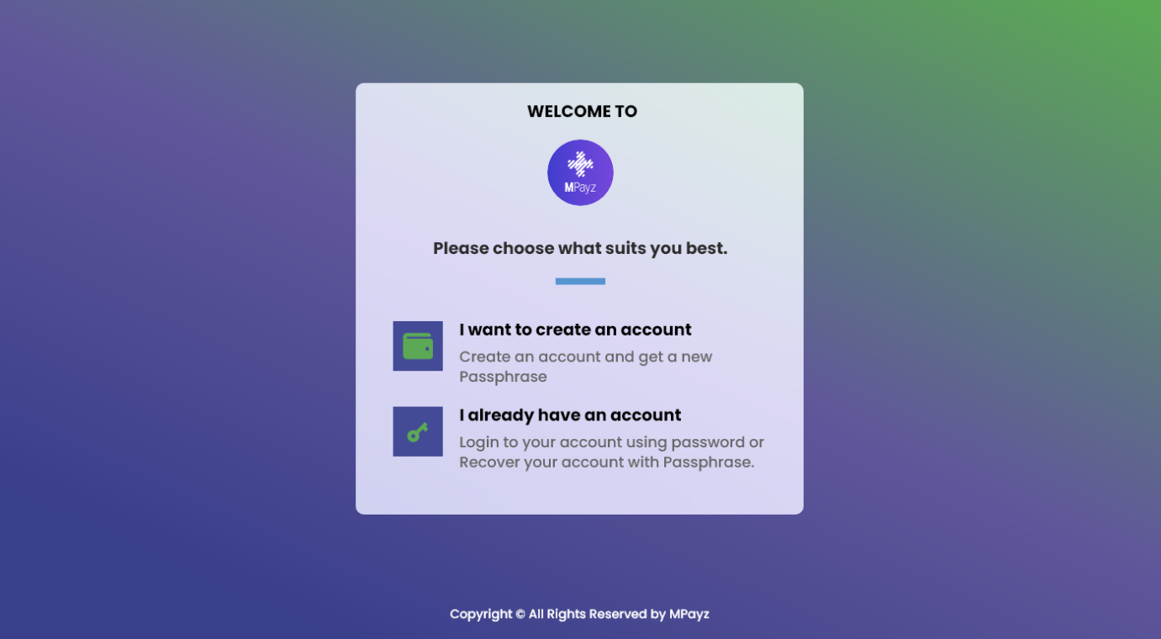

# Passphrase POP-UP

This pop-up will alarm user to save user’s passphrase, and let user know the importance of passphrase

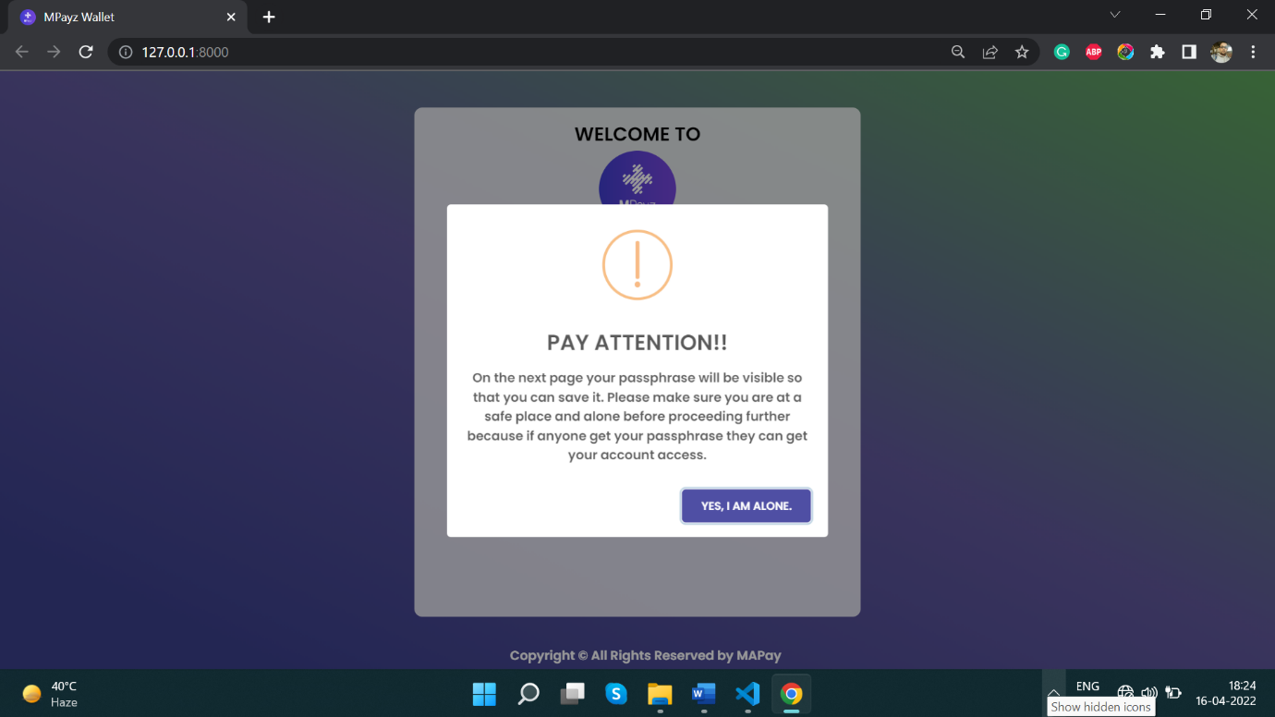

# Create Passphrase

Once the user confirms that user understands the significance of the password, the user will be presented with a 25-word long algorand.

User can regenerate the passphrase as well.

The user can directly copy the passphrase to the clipboard.

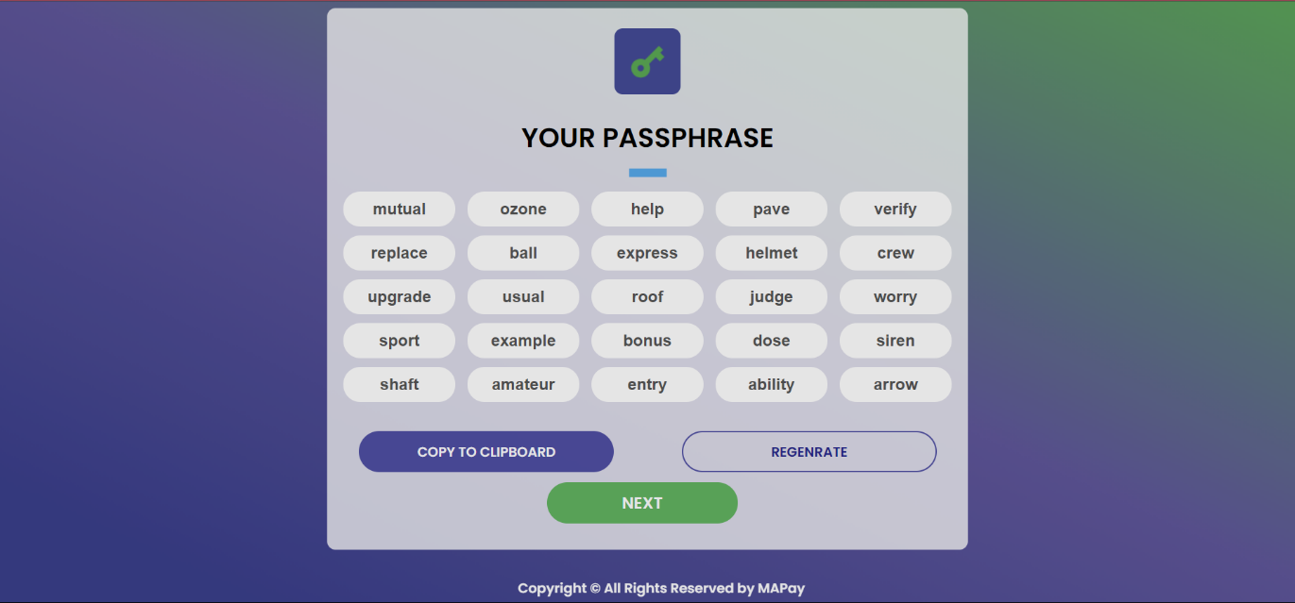

# Verify Passphrase

Once the user has saved the passphrase, user can click next. User will next have to select 5 words from the randomly generated words, to confirm the identity.

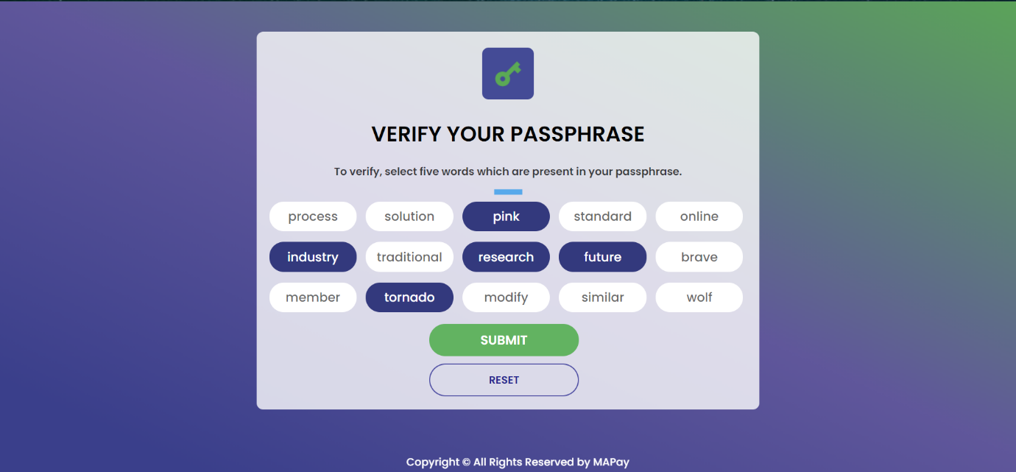

# Login Screen

If the user has successfully created MPaz account and wishes to login, the user must provide user login credentials before being sent to the dashboard.

If by any way the user forgot user login credentials, user can click on “Recover account”.

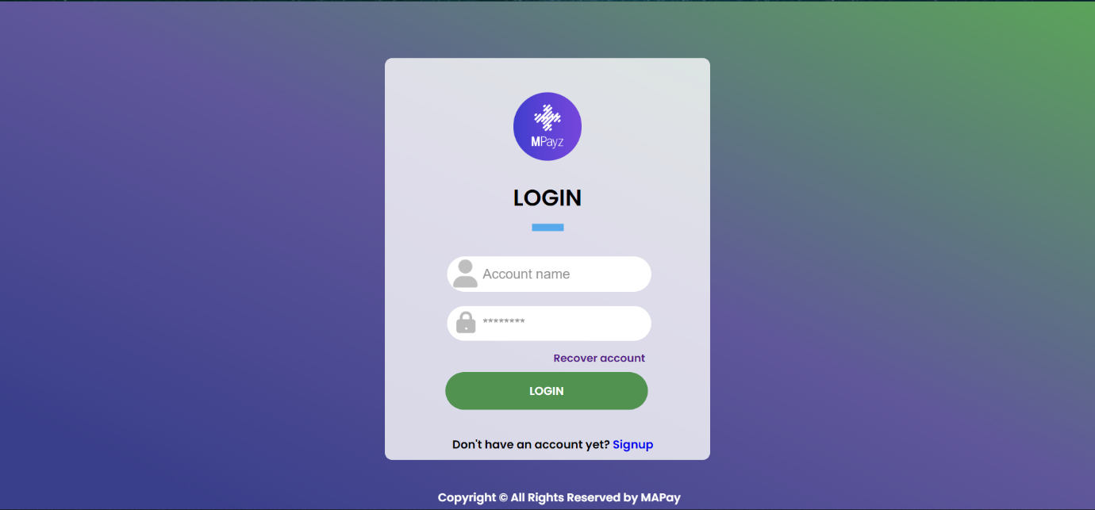

# Recover Account

If a user wants to recover user account, then user need to manually type in each and every passphrase word.

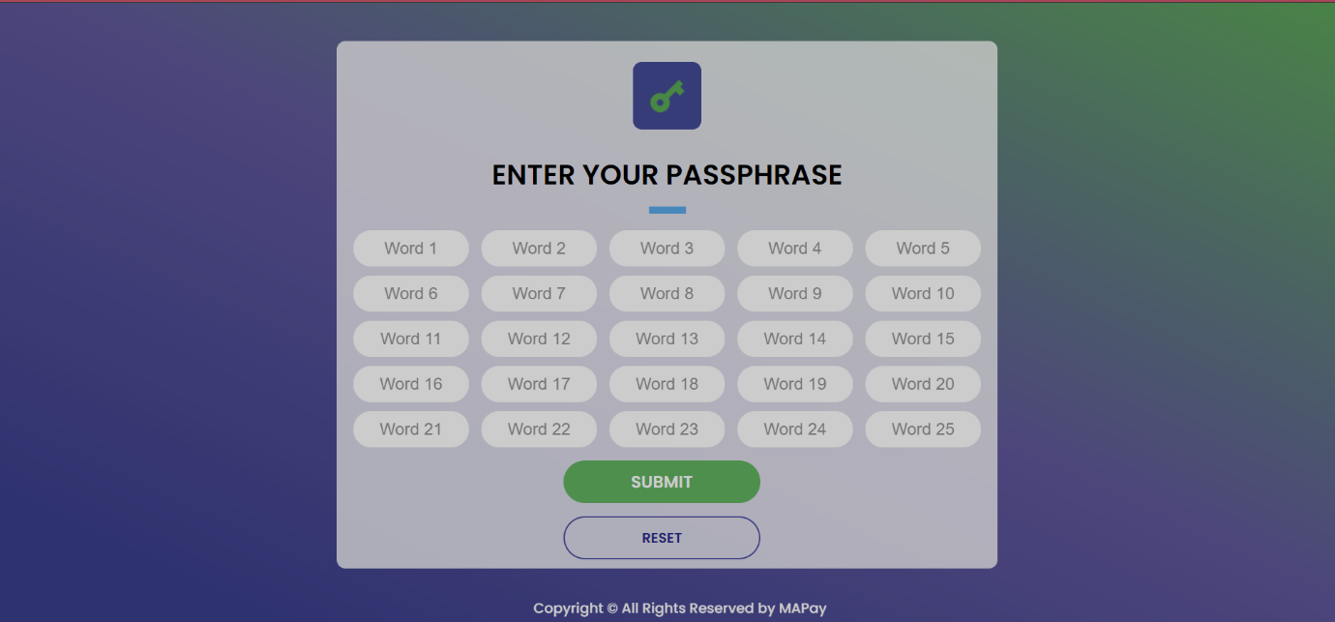

Dashboard

Once the user successfully logins, user will be redirected to the dashboard, where all the details are provided.

User can select between Testnet and Mainnet.

Notifications will contain all the messages, payments requests, etc.

Message will be a service where a user can chat with support or other user(s).

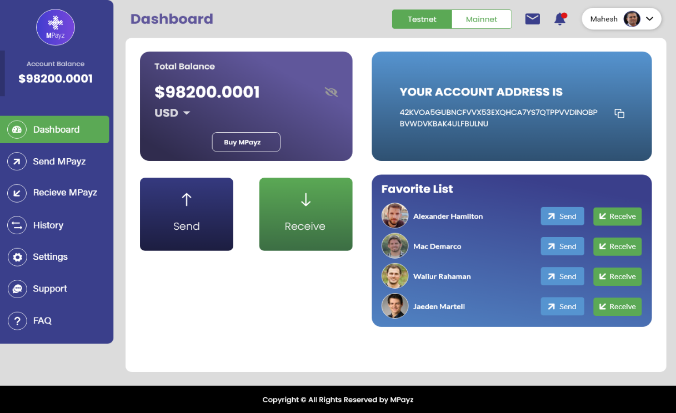  
  
Send

If a user wants to send some MPayz, user can go to here, enter the required details.

We have provided an option of sending to favourite contact; hence user don’t need to enter address.

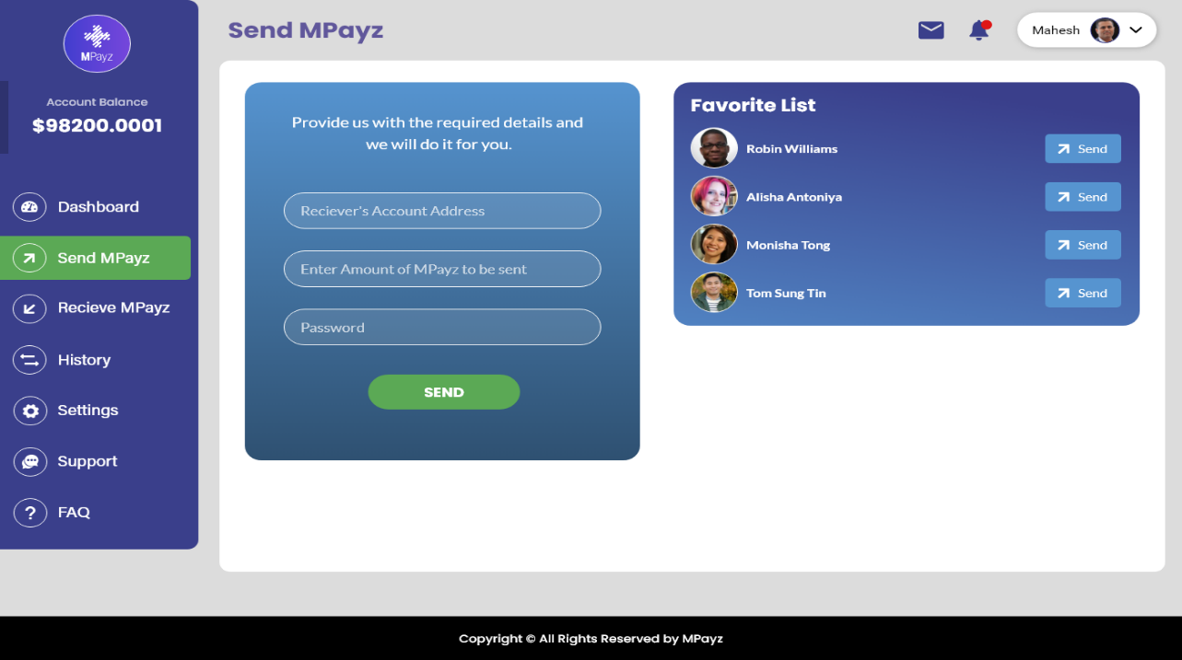

Receive

If user wants to request MPaz or raise some bills, user can do that using the receive form.

User can copy user address using the copy icon or can scan the bar code.

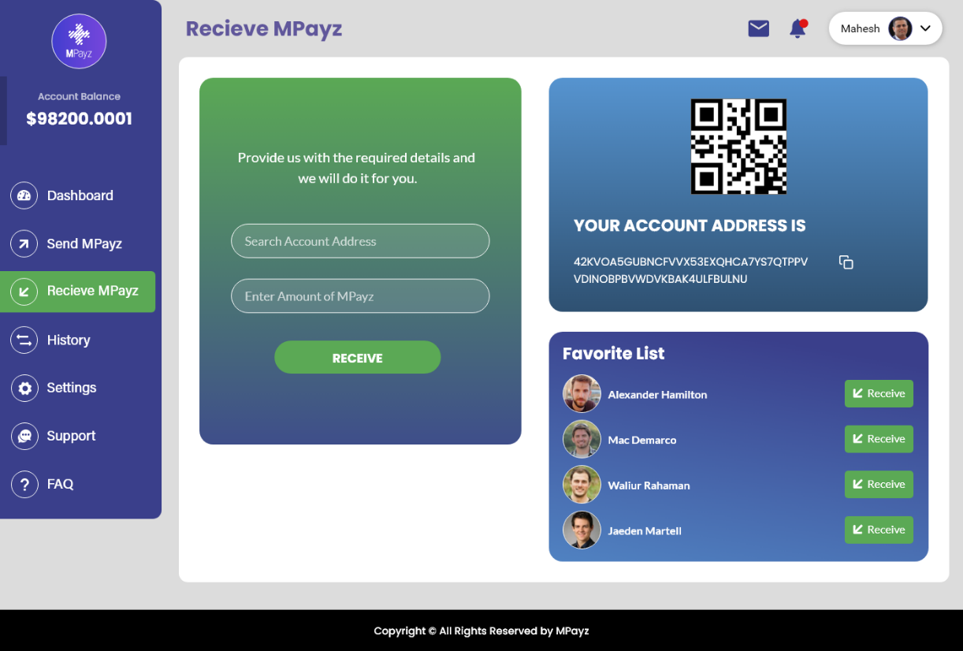  
  
History

User can get all the details of user transactions here.

User can search for a transaction based on the transaction ID.

Transactions can be sorted based on transaction type.

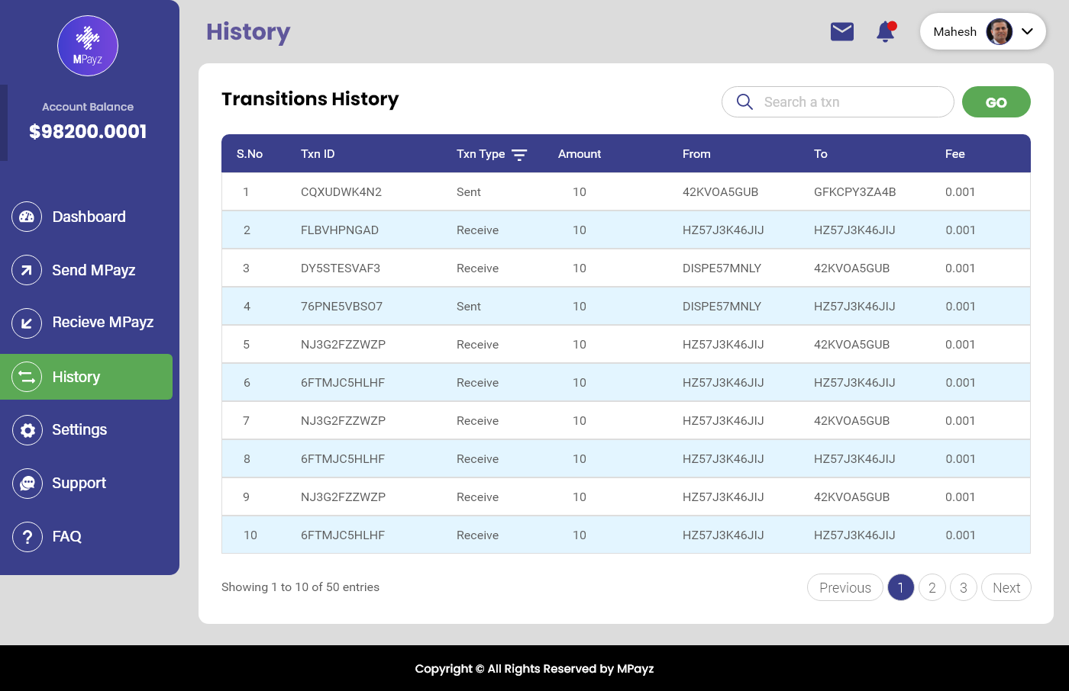

FAQ’s

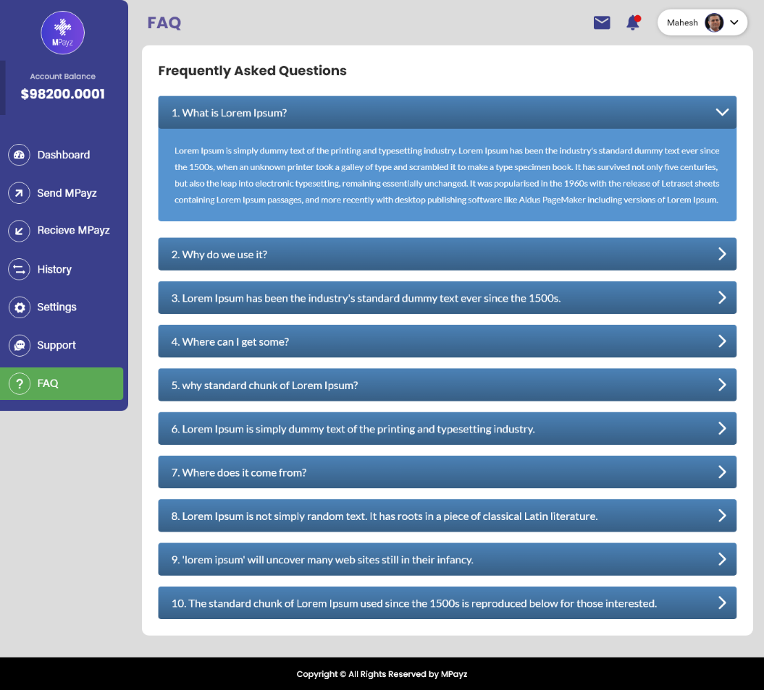

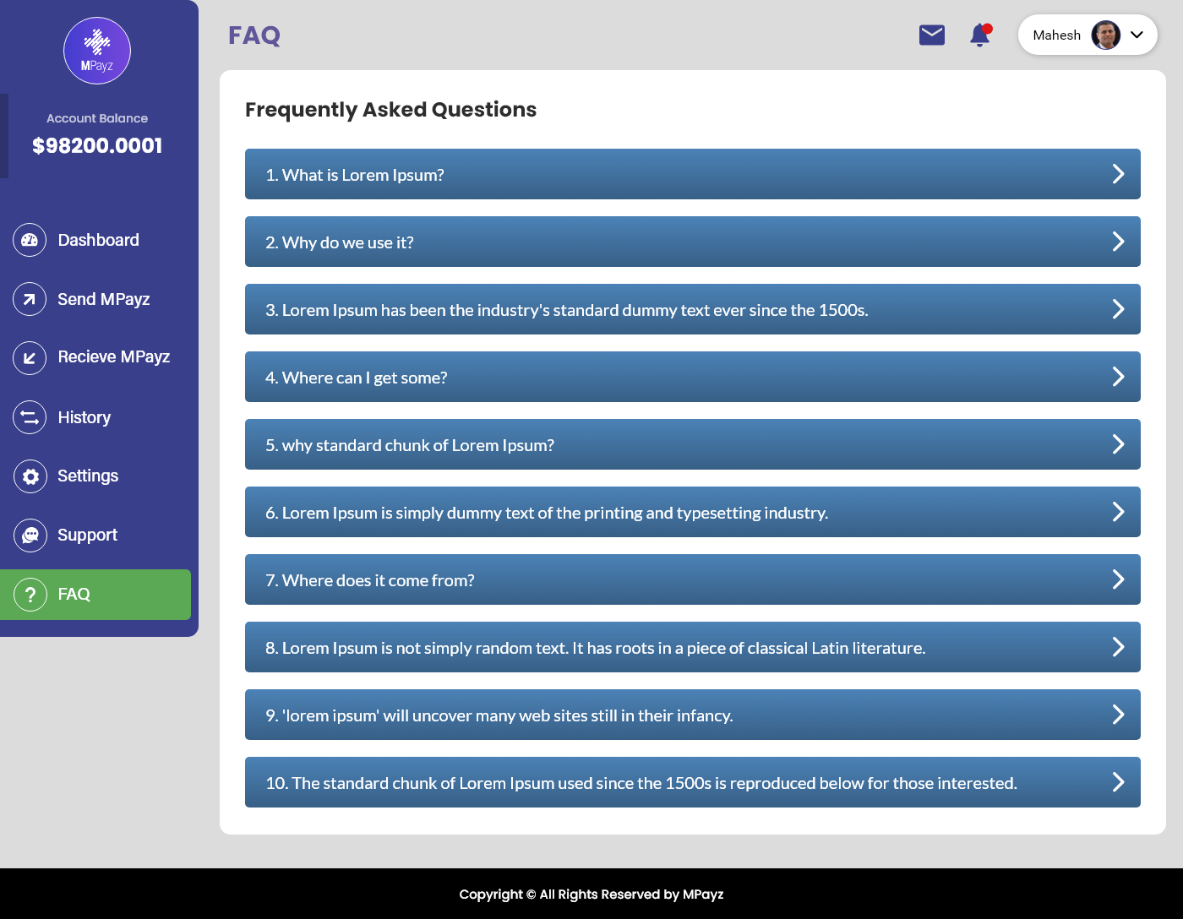

# Support

A user can contact the support, by raising a ticker or though the contact information provided.

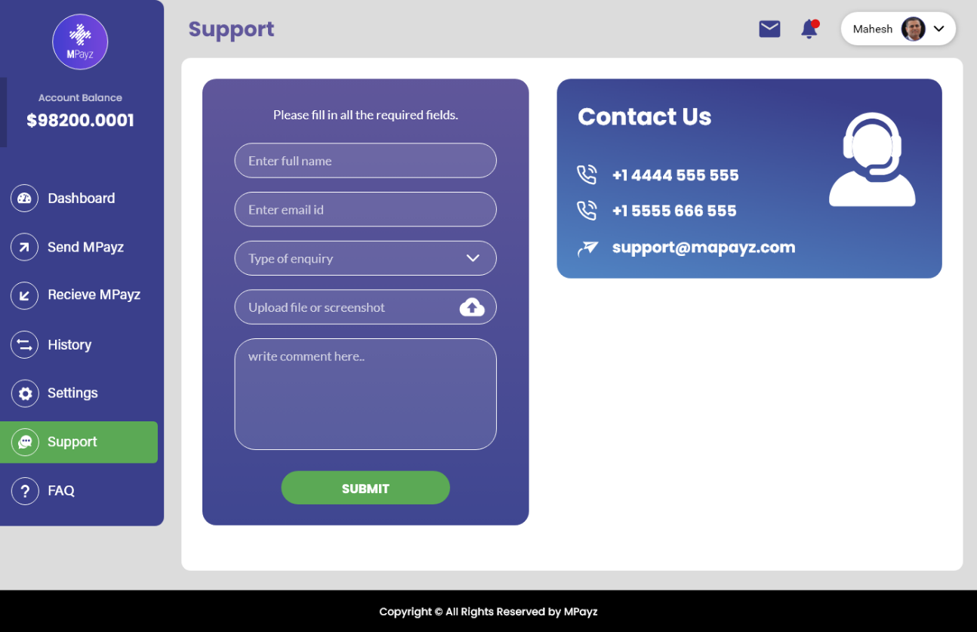  
  
Settings

Under setting you can change and edit your profile details.

